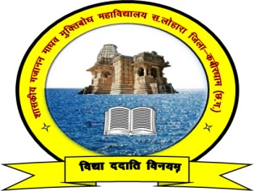

Govt. Gajanan Madhav Muktibodh College, S. /Lohara Dist. –Kabirdham (C.G.)

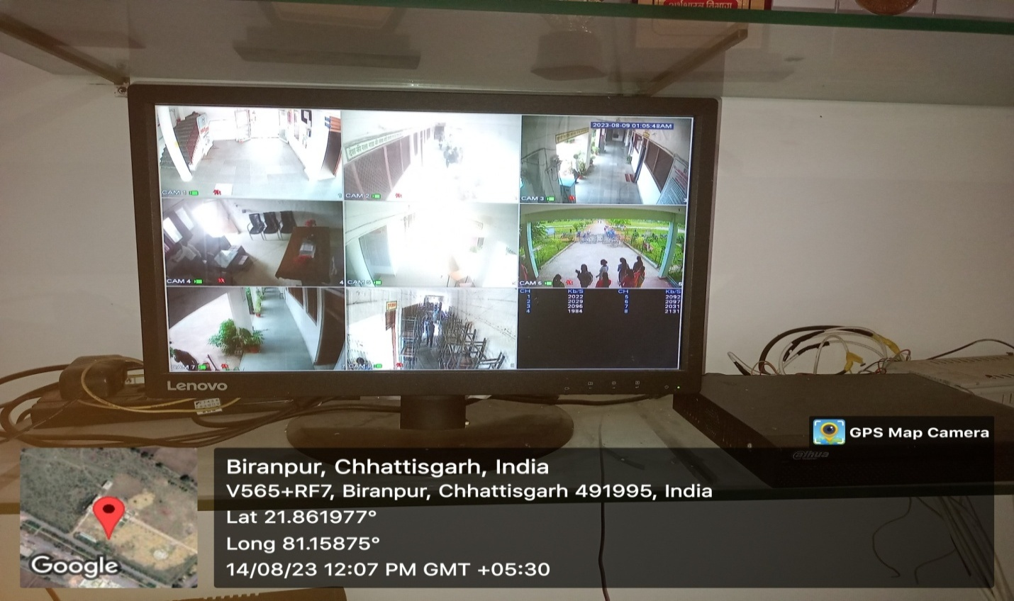

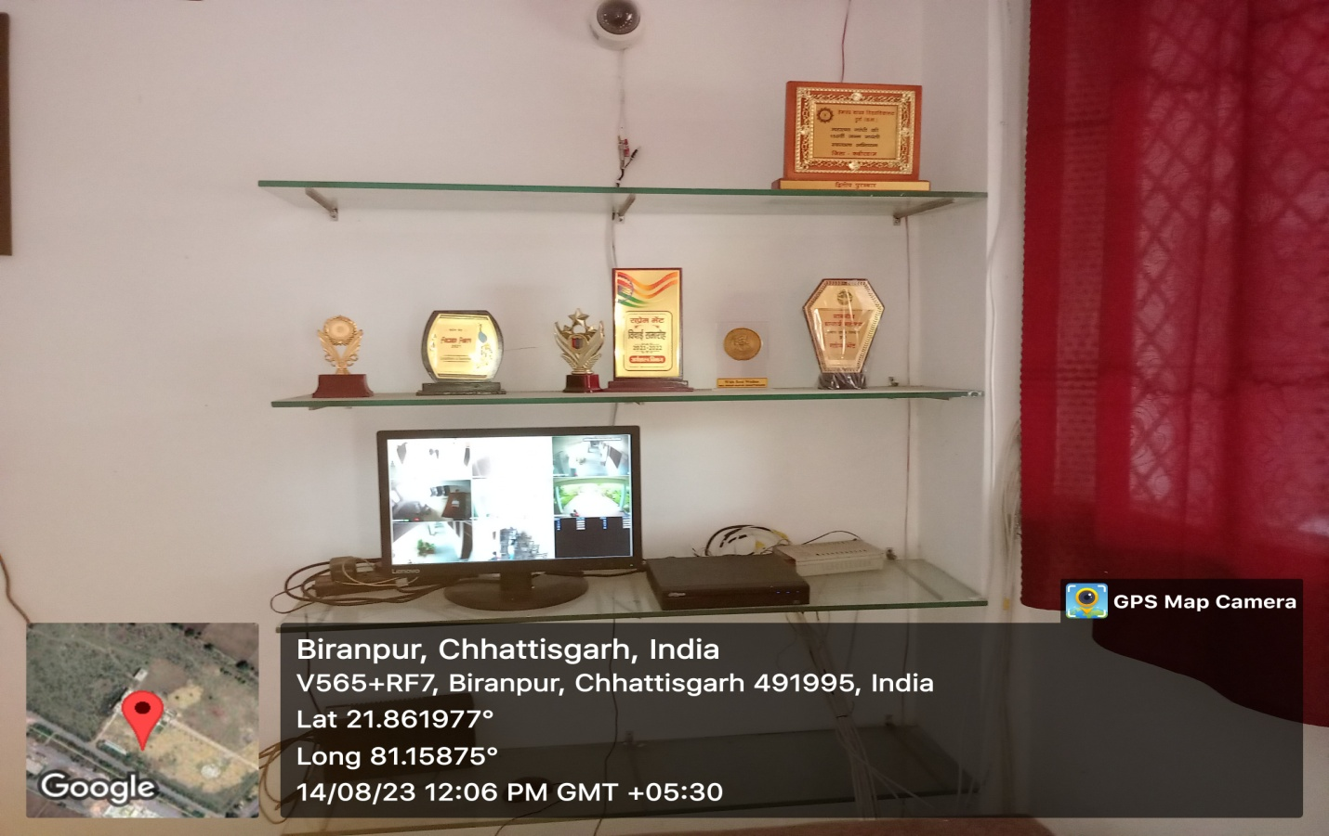

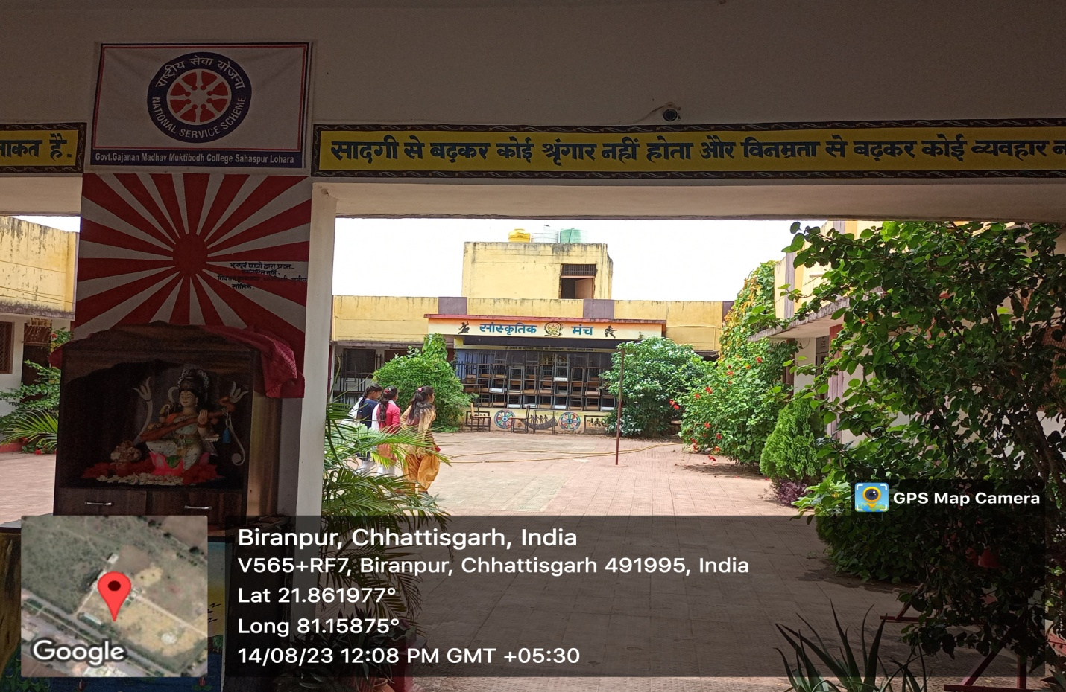

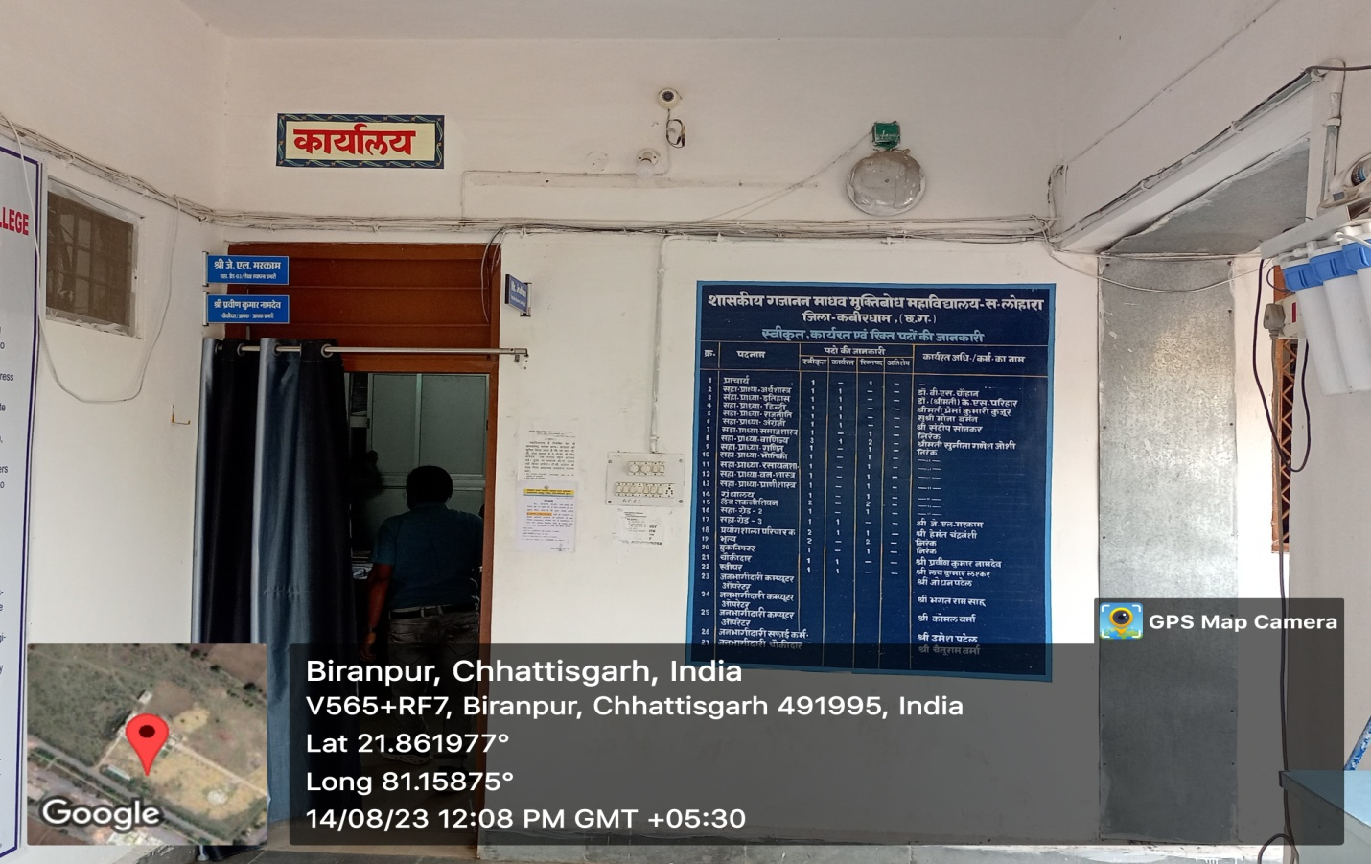

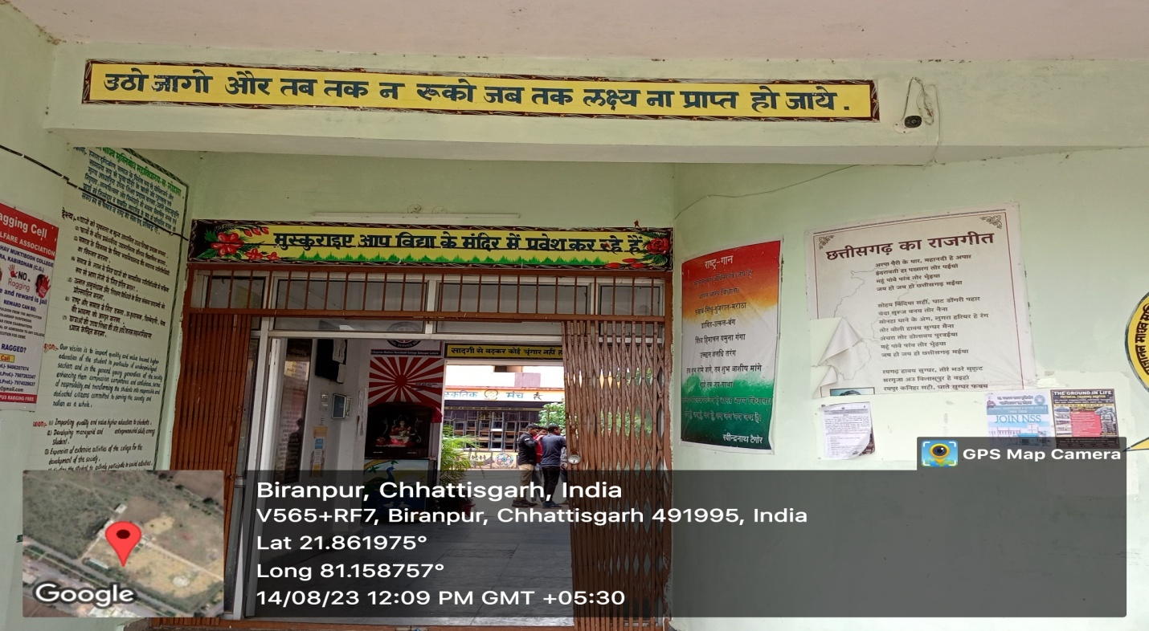

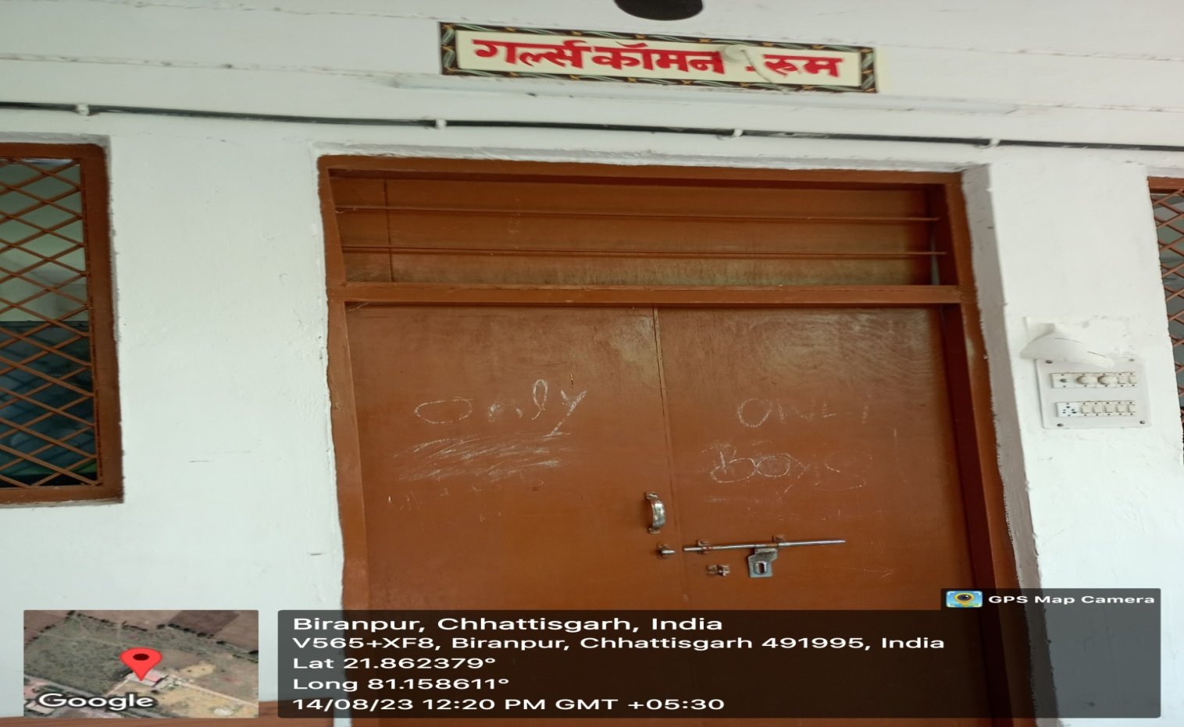

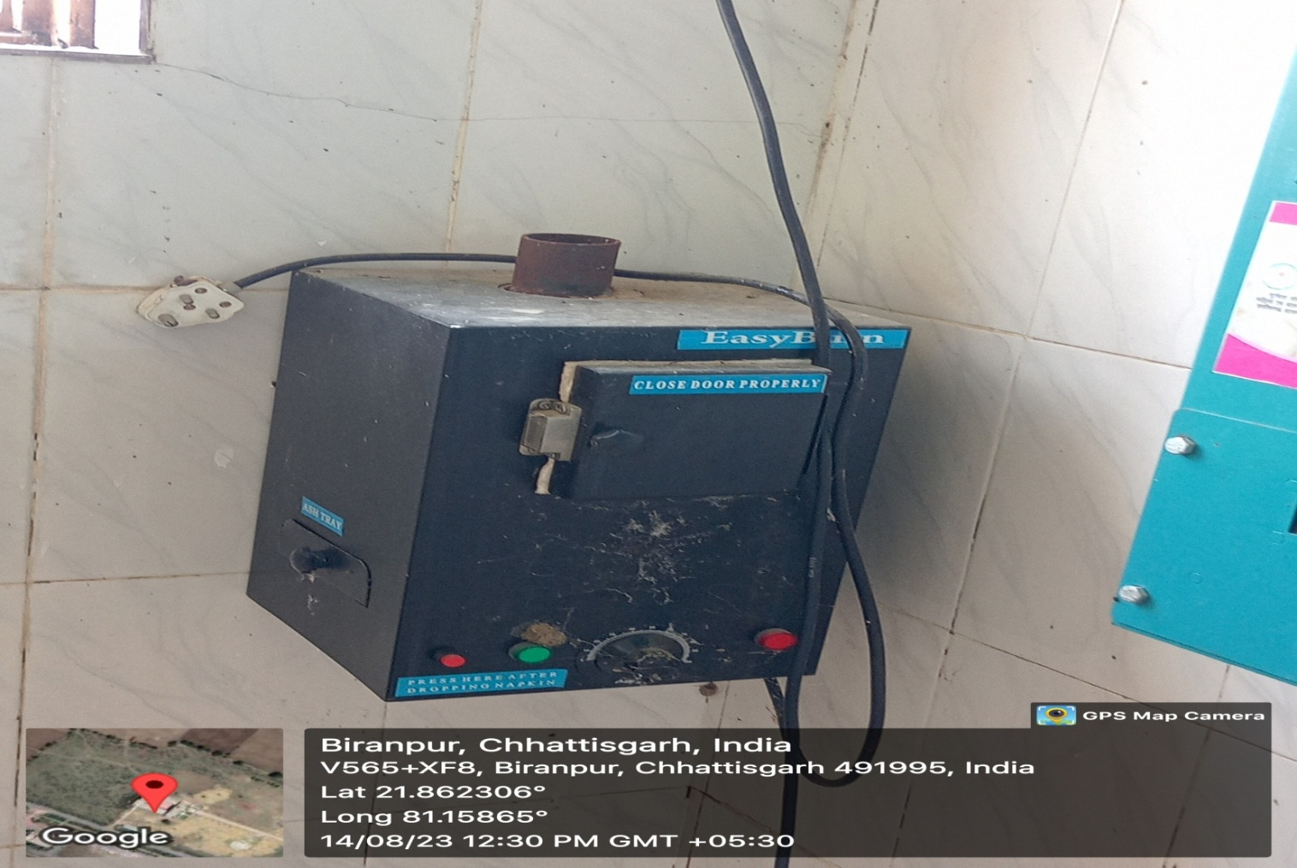

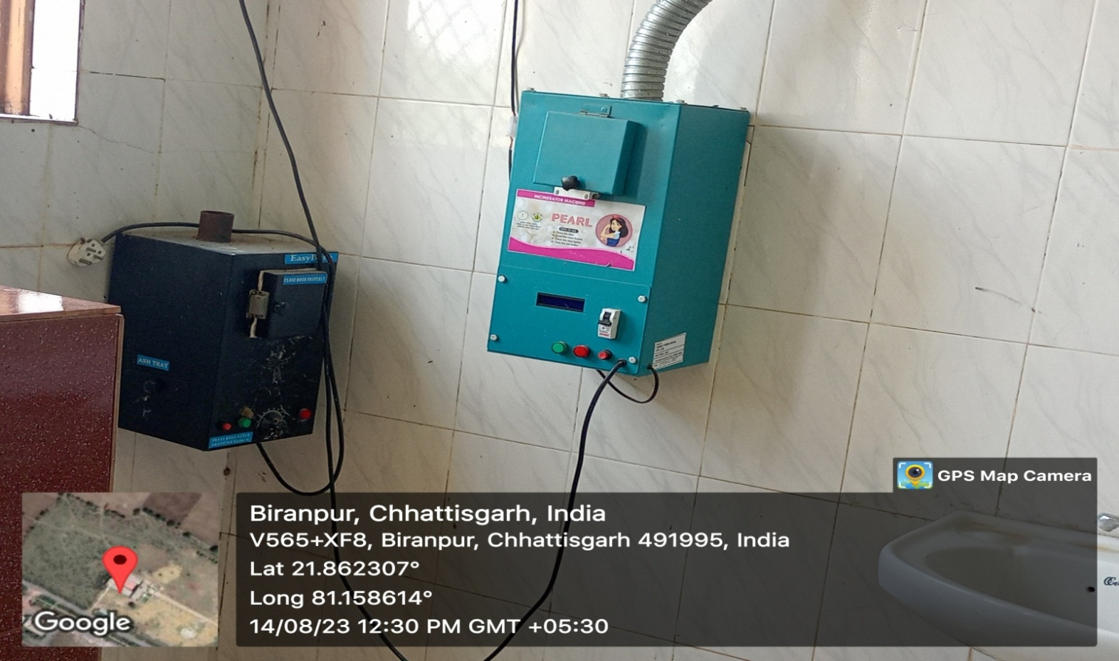

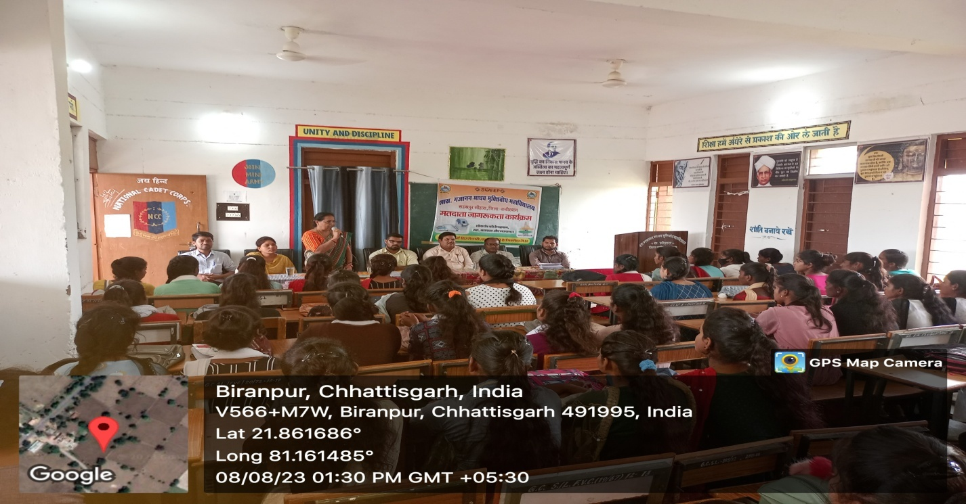

**Parent - Teacher Meeting**

Women and girls comprise half of the planet’s population; their empowerment is essential in expanding economic growth and promoting social development in a sustainable way.

1. Gender inequality remains an everyday reality for the world’s women and girls. It can begin right at the moment of birth and continue throughout the course of a woman’s life.
2. Despite critical advances over the course of recent history, women in all countries and across all socioeconomic levels in society can face various forms of unfair treatment, including discrimination, harassment, domestic violence and sexual abuse. Other forms of abuse that are particularly prevalent in certain countries or cultural contexts include forced marriage, honor killings, deprivation of education, denial of land and property rights, and lack of access to work and to health care.

